**Analysing Gender Disparity in Nollywood: Using Four Evaluation Criteria**

A captivating exploration using data analysis techniques to visualize and uncover insights into gender inequality in Nollywood.



My friends and I went to the cinema to watch one of the most anticipated movies we had been eagerly awaiting. While enjoying the film with a group of friends, some of the ladies in our group expressed their frustration with how Nollywood (the Nigerian film industry) tends to objectify female actors, portraying them primarily as sex symbols. They pointed out that in many Nollywood movies, a female actor is often expected to have an appealing body shape, with well-defined curves, large buttocks if possible, and an attractive breast size that commands attention.

After the movie, we continued our conversation, and the ladies posed some meaningful and critical questions to the guys in our group:

1. Why are female actors stereotyped?
2. Are female actors and filmmakers objectified because the industry is dominated by men?
3. Why does Nollywood infuse elements of romance into its movies?
4. Why are females underrepresented in Nollywood?

They concluded that ladies should not be seen as objects but as creative individuals full of talent, capable of significantly contributing to the industry's development. These questions and conclusions ignited a spark within me, prompting me to delve into data analytics to answer my friends' questions and determine if gender inequalities exist in Nollywood and to what extent.

With these questions on my mind, I set out to use Netflix Nigeria's data between 2013 and 2023 to uncover answers. Over a period of six weeks, I watched over 90% of the movies and TV shows available on Netflix Nigeria, having already seen 50% of the content. This thorough examination allowed me to substantiate my discoveries with concrete examples and observations.

**Article Objectives**

**This article aims to advocate for gender equality within the Nollywood industry through actionable insights and strategic recommendations**. In this article, I will focus on the following key areas:

**Industry Impact and Economic Contribution**:

* Explore the growth of Nollywood over the years and its vital role in the Nigerian economy.

**Quantitative Representation Analysis**:

* + **Directors**: Analyze the total count and proportion of male versus female directors in movies and TV shows from 2013 to 2023. Identify the top five (5) male and female directors.
  + **Producers**: Evaluate the total count and proportion of male versus female producers in movies and TV shows from 2013 to 2023. Identify the top five (5) male and female producers.
  + **Lead Roles**: Analyze the total count and proportion of male versus female lead and co-lead roles from 2013 to 2023.

**Content Analysis**:

* + **Bechdel Test**: Assess the success and failure rates of the Bechdel Test in movies and TV shows. Analyze how many films directed or produced by females passed the test.

**Call for Action**:

* + Identify six (6) strategic focal points to address gender disparity and promote gender equality in Nollywood.

**Let's break it down.**



This concise text outlines the significant stages involved in the article through a simple yet informative graphic. However, for some, reading textual descriptions might be more accessible than interpreting graphical representations of data wrangling processes.

1. Data Collection: Acquired via Web Scraping using Python.
2. Preprocessed data in Excel and Tableau.
3. Data Cleaning: Rectifying spelling errors, eliminated blank entries, and omitted irrelevant columns specific to the project's scope.
4. Data Transformation: Altered the data to facilitate analysis.
5. Data Visualization: Done with Tableau and PowerPoint.

**Act 1 - Industry Impact and Economic Contribution:**

**Growth and Economic Contribution**

Nollywood, Nigeria's film industry, plays a crucial role in the economy by offering numerous employment opportunities. It is the world's second-largest film producer, with UNESCO reporting around 2,500 movies and TV shows produced annually. Since its inception in the early 1990s, Nollywood has grown exponentially, becoming a significant cultural and economic force in Nigeria and beyond. From 2017 to 2020, the industry saw an impressive 477.6% increase in annual production, reaching 2,599 productions in 2020.

Over the past two decades, Nollywood's steady growth has led to its contribution of approximately 1.3% to Nigeria's GDP in 2021. According to PwC, this contribution was 2.3% of the GDP, equivalent to around $600 million. Future projections suggest that Nollywood is on track to achieve an annual value of approximately $1 billion. Nollywood is a powerhouse in the Nigerian economy, driving employment, revenue generation, technological advancements, cultural export, and economic diversification. Its impact extends beyond the film industry, influencing various sectors and contributing significantly to Nigeria's economic development.

**Act 2 - 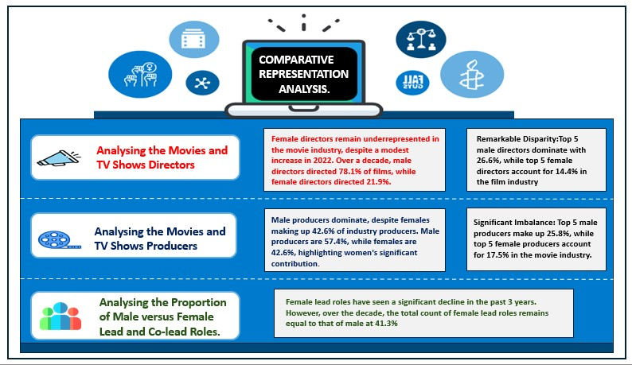Quantitative Representation Analysis:**

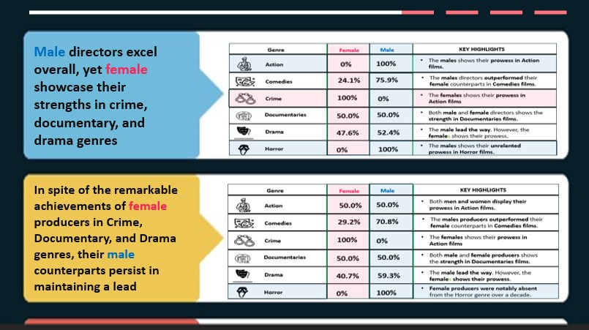

**Act 3 - 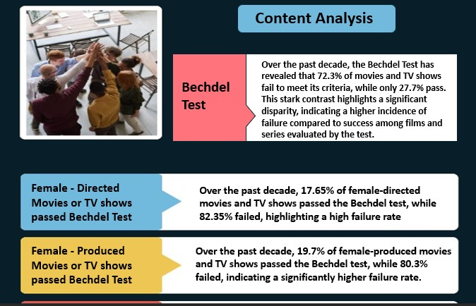Content Analysis:**

***Interlude:***

1. **Bechdel Test Observations**

* **Widespread Imbalance**: A considerable number of movies and TV shows fail to meet the Bechdel test criteria, which assesses the representation of women in the film Industry.
* **Comparative Rates**: The proportion of productions that do not satisfy the Bechdel test notably exceeds those that do, highlighting an area for improvement in gender representation.

**This crucial reminder underscores that while the Bechdel test provides a valuable starting point for discussing gender representation in film, it's essential not to rely solely on it when assessing a movie's quality or the depth of its characters. Genuine diversity and complex female characters are vital for achieving a truly equitable portrayal of genders in the film industry**.

1. **Discussion**

**Despite its substantial contribution to the GDP, the Nollywood industry struggles with ongoing gender disparities. As my friends often highlight, women in Nollywood are noticeably underrepresented and frequently stereotyped into specific roles, particularly those infused with elements of romance.**

The analysis below provides a comprehensive overview that addresses my friends’ concerns regarding gender disparity in Nollywood:

* **Directorship**: The analysis reveals that **male directors led 77.9% of movies and TV shows, whereas female directors helmed 22.1%.** This starkly highlights the dominance of male directors, particularly the top five, in the film industry.
* **Production**: **Male producers accounted for 57.8%, with female producers making up 42.2%**. Despite this near balance, there remains a significant disparity, notably with the top five male producers eclipsing their female counterparts in the movie industry.
* **Lead Roles**: No significant gender disparity was observed in male versus female lead and co-lead roles.
* **Bechdel Test**: There was a substantial 433.3% increase in Bechdel test failures in 2018, indicating a notable 44.6% gap between failure and success rates. Failures constituted 72.3%, while successes accounted for 27.7%.

**Act 4 - Recommendations:** Call for Action

To effectively address gender disparities in Nollywood, strategic initiatives are crucial. The strategic framework, grounded in best practices, outlines six key priorities aimed at tackling these disparities and promoting gender equality. These areas of focus aim to empower female voices and foster industry-wide equality by:

**6 Strategic Foci to** **Address Gender Disparity and Promote Gender Equality in Nollywood.**

1. Enhancing Representation, Visibility, and Embracing Diversity

2. Empowering Networks and Mentorship Initiatives

3. Advancing Industry Advocacy and Awareness

4. Crafting Stories with Gender Sensitivity

5. Providing Financial Assistance

6. Recognizing achievements, enhancing distribution, and promoting inclusivity

**Conclusion**

This report provides a thorough examination of Netflix Nigeria's data concerning Gender Disparity in Nollywood, empowering stakeholders to make well-informed decisions and implement strategies aimed at enhancing gender equality within the industry. Through the cultivation of an inclusive atmosphere, the acknowledgment and celebration of females’ achievements, and the active challenge of stereotypes, we can cultivate a film industry that is not only more equitable but also more vibrant and enriching for all involved.